ALICEBLUE:

Process of installing libraries:

Open command prompt (start menu --> type cmd)

pip install pya3

pip install flask

pip install xlwings

pip install pandas

pip install requests

pip install ta

pip install pandas_ta

pip install pyotp

1. Download all the files of Alice Blue from Google drive.
2. Move them to your IntelliJ Project Folder.
3. Then, open IntelliJ Project and open Terminal as shown.

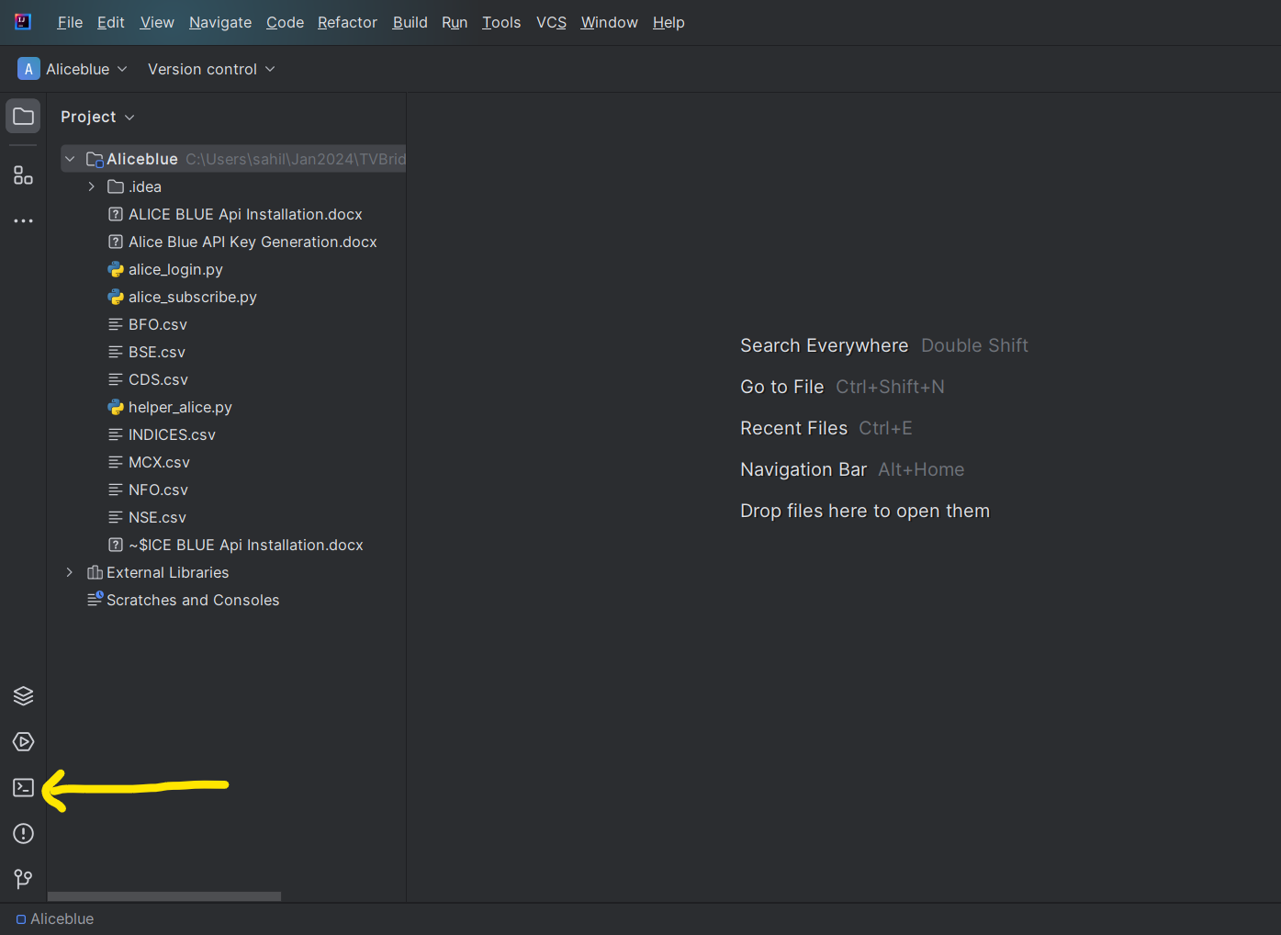

1. Then write the following line in terminal.

pip install pya3 flask requests pandas pytz ta pandas_ta

1. This will install all required libraries for Alice Blue.

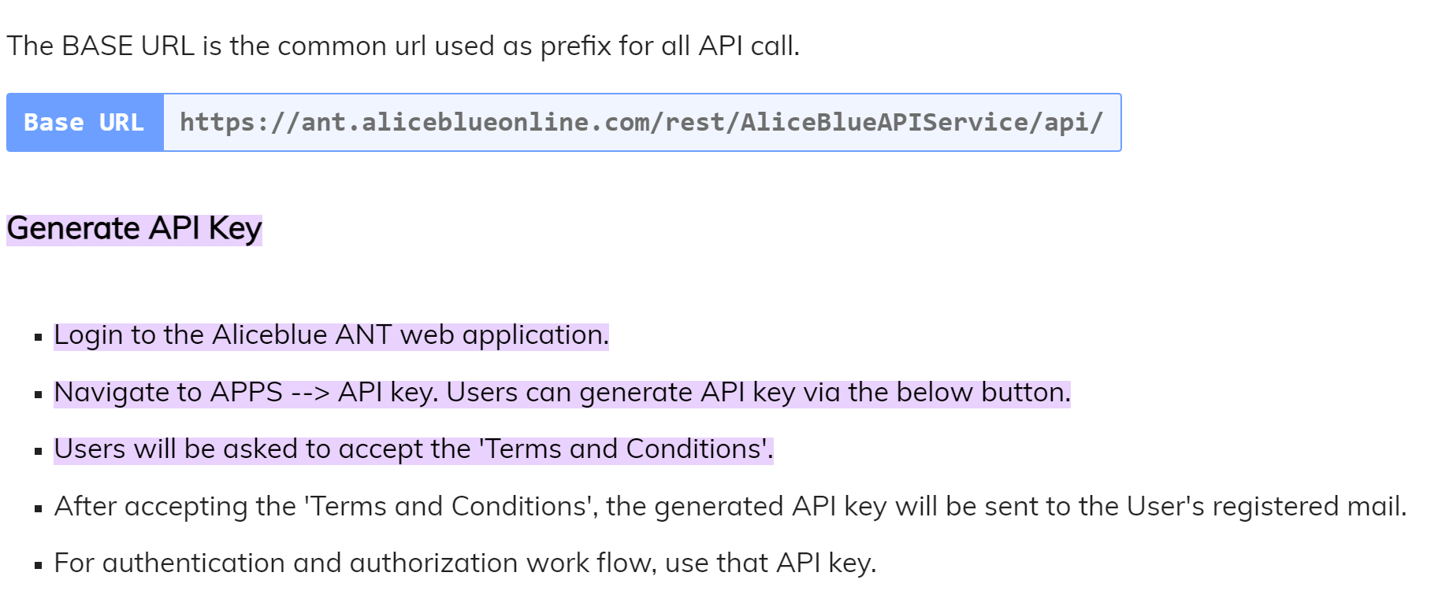

After login page enter TOTP / OTP

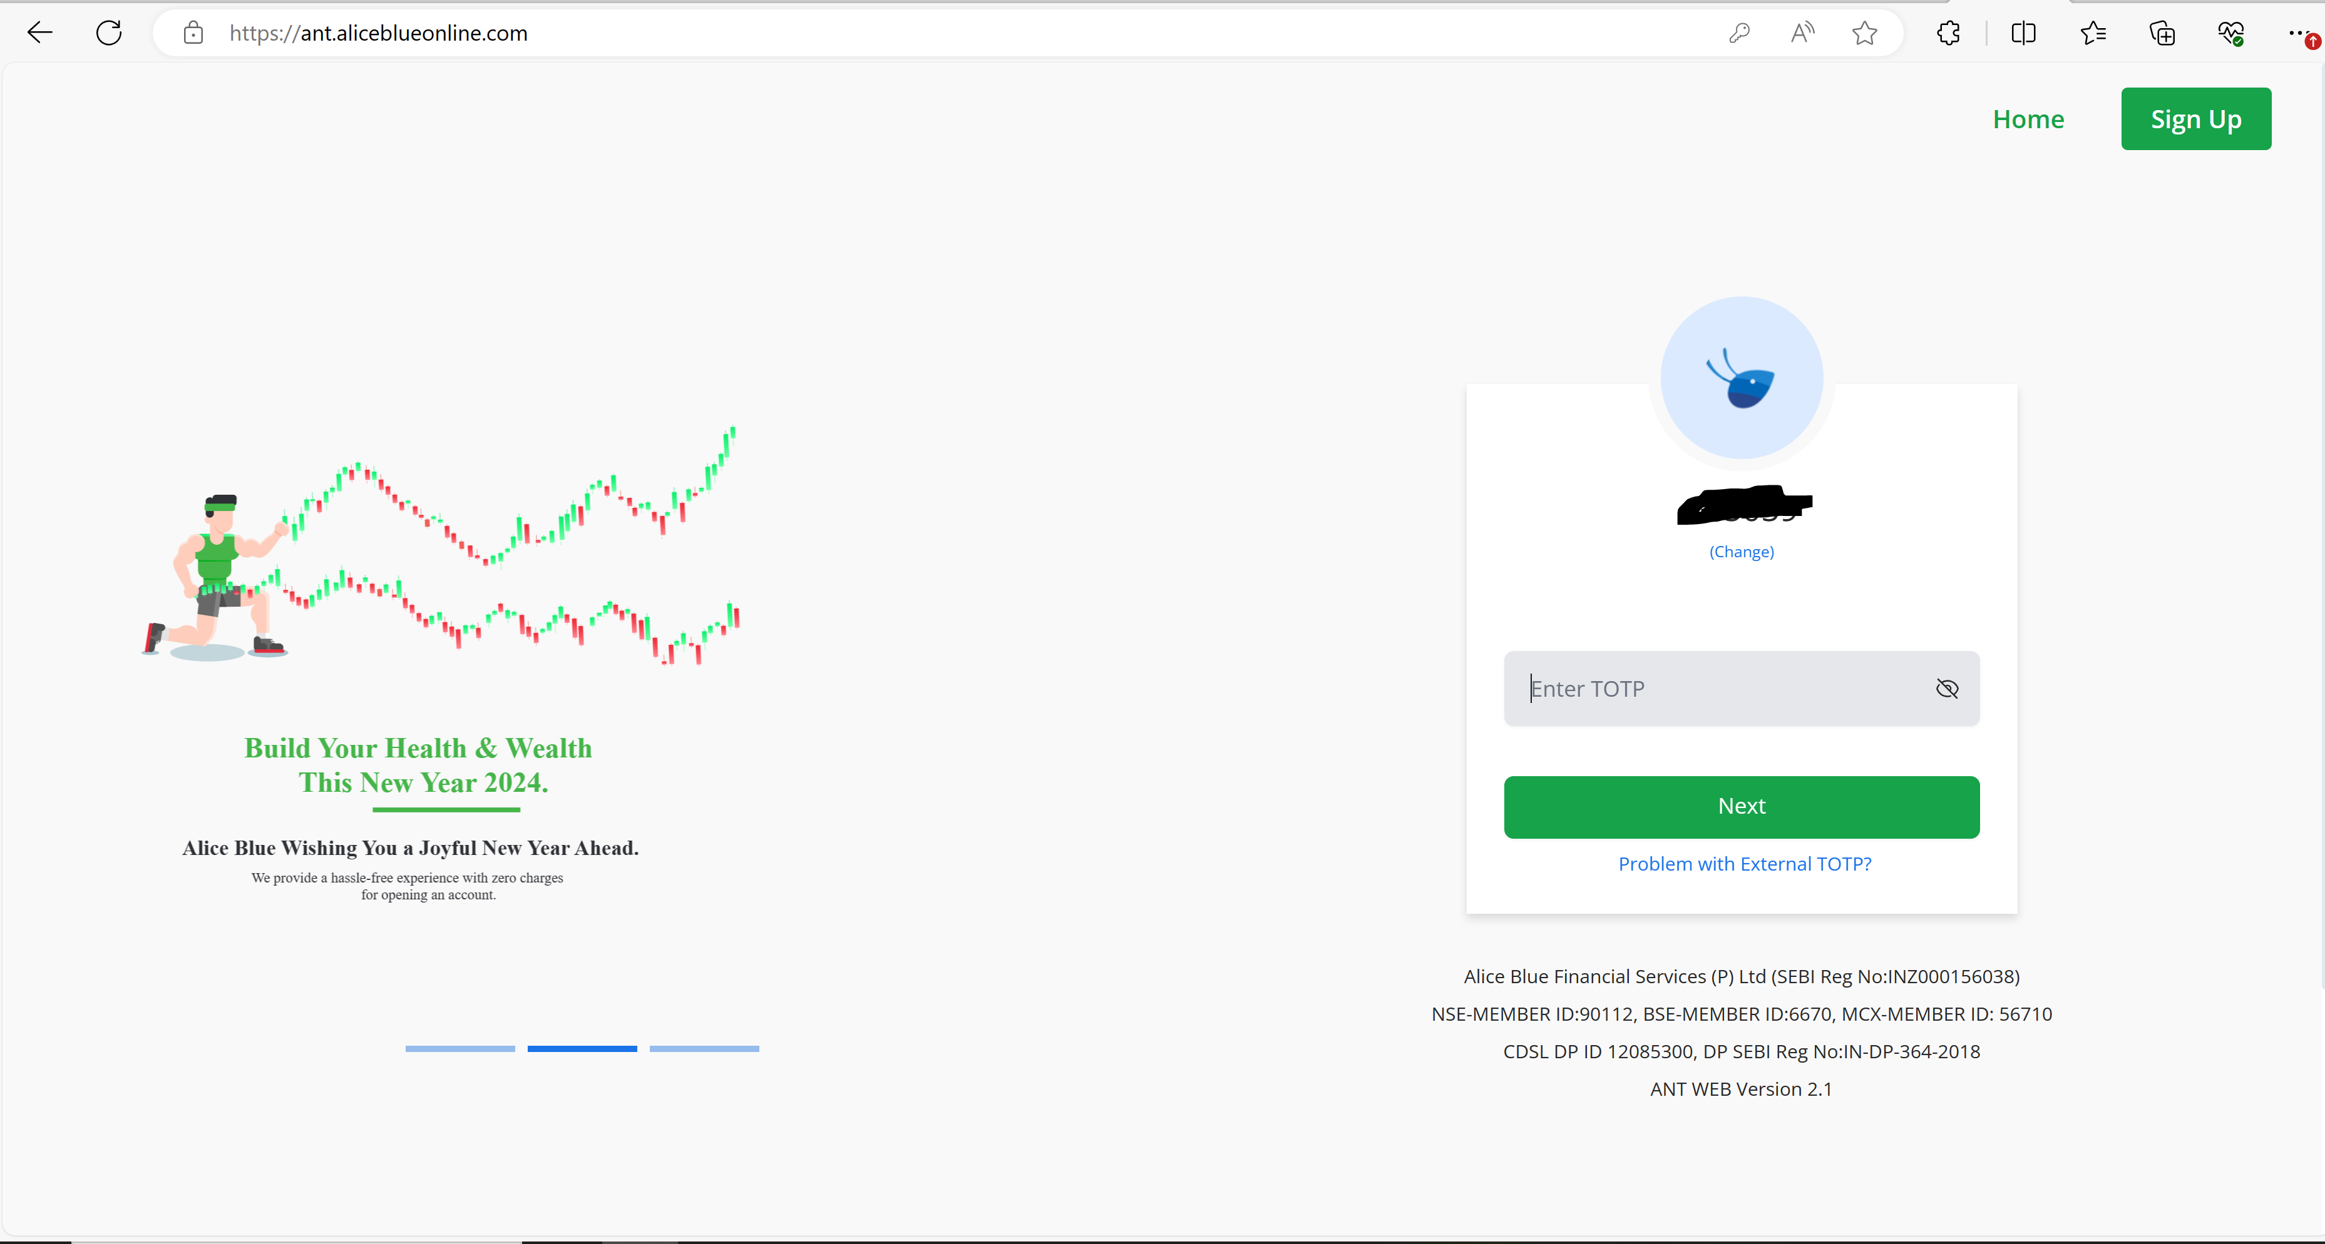

Once Login, Click on Apps, as shown below

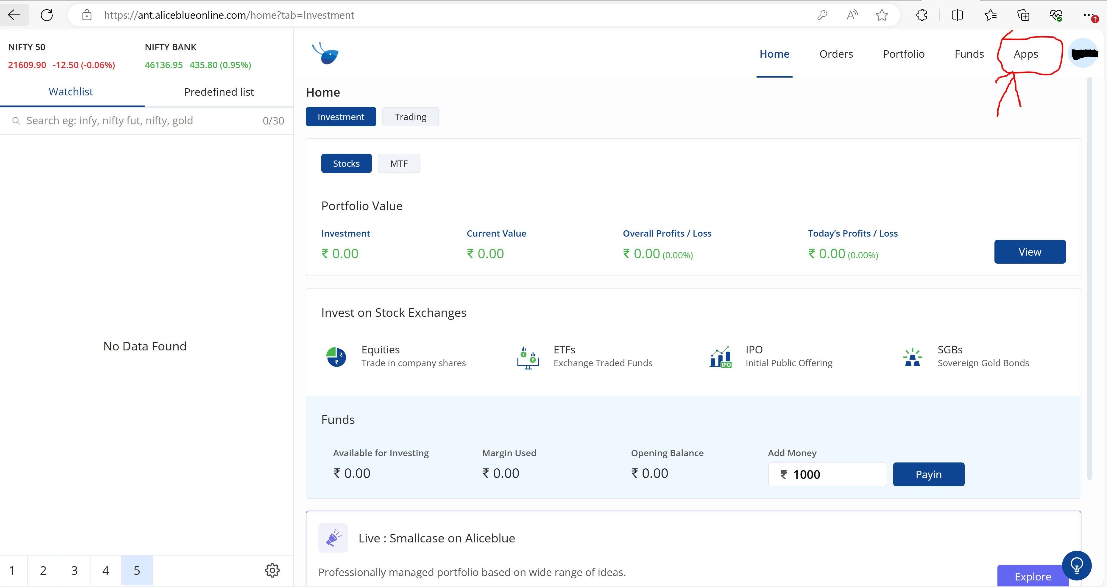

Click on API Key, as shown below

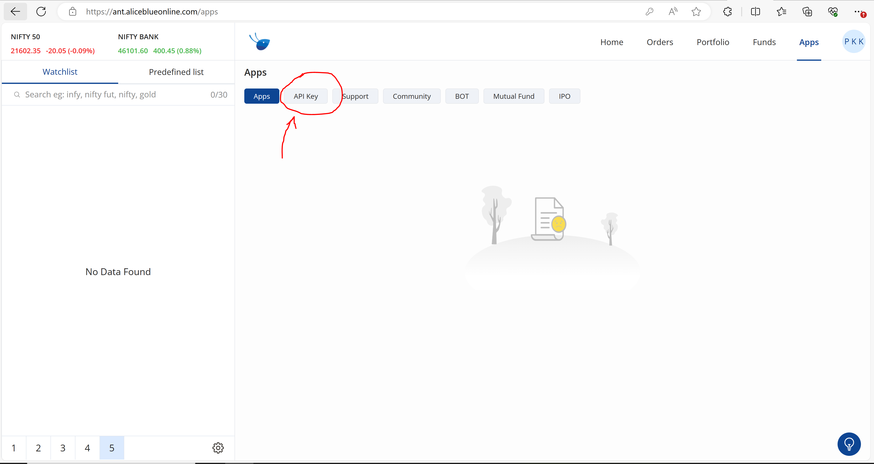

For new API creation, There wil be a generate API option. Click on that. As I have already generated API Key earlier, I am getting option to Regenerate API KEY. We can copy this API code.

